PROJECT REPORT

AutoSort Bin
An IoT-Based Smart Waste Segregation Dustbin
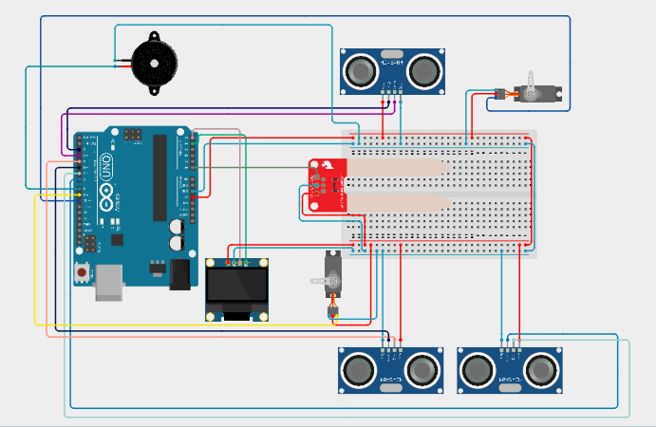

Automatic Lid Control | Moisture-Based Segregation | Dual-Compartment Monitoring

Submitted by
PILLA JOSHI
Domain: Internet of Things (IoT) / Embedded Systems
Platform: Arduino Uno R3

Table of Contents

1. Abstract 3
2. Introduction 3
3. Objectives 3
4. System Overview 4
5. Working Principle 4
5.1 Object Detection and Lid Operation 4
5.2 Moisture-Based Waste Segregation 5
5.3 Compartment Fill-Level Monitoring 6
6. Hardware Components (Bill of Materials) 7
7. Software and Libraries 8
8. Circuit Design and Simulation 8
9. Results and Discussion 9
10. Advantages 10
11. Applications 10
12. Limitations and Future Scope 11
13. Conclusion 11
14. References 11

1. Abstract
AutoSort Bin is an IoT-based smart waste segregation dustbin designed to automate the collection and sorting of household and institutional waste into dry and wet categories. The system uses an Arduino Uno microcontroller along with three ultrasonic distance sensors, a soil moisture sensor, two servo motors, a buzzer, and a 0.96-inch OLED display to detect approaching waste, open and close the main lid automatically, classify the waste as wet or dry based on its moisture content, direct it into the correct compartment through a servo-controlled flap, and continuously monitor the fill level of both compartments. When either compartment (or both) becomes full, the system alerts users through a combination of a distinct buzzer pattern and an on-screen OLED message, prompting timely disposal. This report documents the objectives, working principle, hardware and software design, circuit implementation, simulation results, applications, and future scope of the AutoSort Bin project.

2. Introduction
Improper segregation of waste at the source is one of the leading causes of inefficient waste management in urban and semi-urban areas. Mixed waste increases the cost and complexity of recycling, contributes to landfill overflow, and creates unhygienic conditions when bins are left unattended after reaching full capacity. Manual segregation is often inconsistent, as it depends entirely on user awareness and discipline.
The AutoSort Bin project addresses this problem by introducing automation at the point of disposal. Rather than expecting the user to sort waste manually, the system automatically identifies whether the waste being disposed of is wet or dry using a moisture sensor and directs it into the corresponding compartment using a servo-driven flap mechanism. In addition, the system continuously tracks the fill level of each compartment using ultrasonic sensors and proactively notifies users when a compartment needs to be emptied, reducing overflow and manual monitoring effort.

3. Objectives
▸ To design a touch-free, motion-triggered lid that opens automatically when waste is brought near the bin.
▸ To automatically classify waste as wet or dry using a moisture sensor as it is deposited.
▸ To mechanically segregate waste into separate dry and wet compartments using a servo-actuated flap.
▸ To continuously monitor the fill level of both compartments using ultrasonic sensors.
▸ To provide real-time visual feedback to the user through an OLED display.
▸ To provide distinct audible alerts (via buzzer) for dry-full, wet-full, and both-full conditions so that the correct compartment can be identified without checking the display.

4. System Overview
The AutoSort Bin operates on a simple but effective sensing-and-actuation logic built entirely around the Arduino Uno. Three ultrasonic sensors serve three independent purposes, while a single moisture sensor and a pair of servos handle the actual sorting mechanism. The system logic can be summarized as follows:
Sensor / Actuator | Position | Function
Ultrasonic Sensor #1 (TRIG1/ECHO1) | Bottom / Front of bin | Detects an approaching object and triggers the main lid to open
Ultrasonic Sensor #2 (TRIG2/ECHO2) | Top-left, inside Dry chamber | Measures fill level of the DRY compartment
Ultrasonic Sensor #3 (TRIG3/ECHO3) | Top-right, inside Wet chamber | Measures fill level of the WET compartment
Soil Moisture Sensor (A0) | Waste drop chute | Determines whether the deposited waste is wet or dry
Servo Motor 1 (Pin 10) | Main lid | Opens/closes the lid for waste entry
Servo Motor 2 (Pin 9) | Sorting flap | Diverts waste into the dry or wet compartment
Buzzer (Pin 8) | Enclosure exterior | Audible full-bin alerts (1/2/3 beep patterns)
OLED Display (I2C) | Front panel | Real-time status and instructional messages

The main lid and the compartment-level sensors are functionally independent: the bottom sensor only controls waste entry, while the two top sensors only monitor how full each compartment already is. This separation keeps the lid-opening behaviour responsive and prevents false alerts from affecting normal waste disposal.

5. Working Principle

5.1 Object Detection and Lid Operation
When a user approaches the bin with waste, the bottom-mounted ultrasonic sensor (TRIG1/ECHO1) continuously measures the distance to the nearest object. If this distance falls below the configured threshold (20 cm), the Arduino commands Servo Motor 1 to rotate the lid to its open position. The OLED simultaneously displays “BIN OPENING...” followed by “BIN OPEN.” The lid remains open for a fixed duration (5 seconds) to allow the waste to be dropped in, after which it closes automatically and the display updates to “BIN CLOSED.”
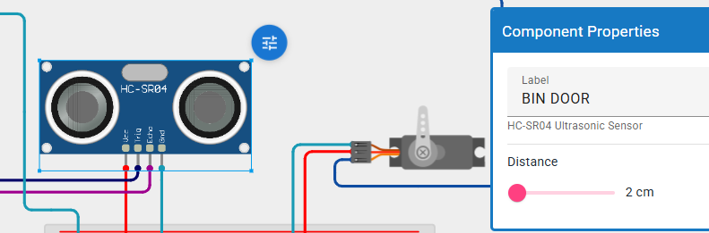
Fig 5.1: Bin door (main lid) opening automatically when an object is detected by the bottom ultrasonic sensor
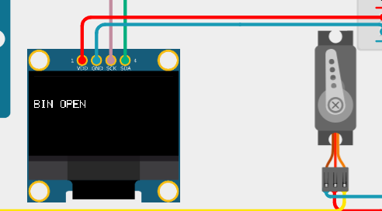
Fig 5.2: OLED display confirming “BIN OPEN” status

5.2 Moisture-Based Waste Segregation
As soon as the lid cycle completes, the system reads the analog value from the soil moisture sensor placed along the waste drop path. If the reading is below the wet threshold (500), the waste is classified as dry; otherwise, it is classified as wet. Based on this classification, Servo Motor 2 (the sorting flap) rotates to one of two positions — tilting the flap toward the dry compartment or the wet compartment — and then returns to its neutral (center) position, ready for the next item. The OLED simultaneously displays either “DRY WASTE DETECTED” or “WET WASTE DETECTED” to confirm the classification to the user.
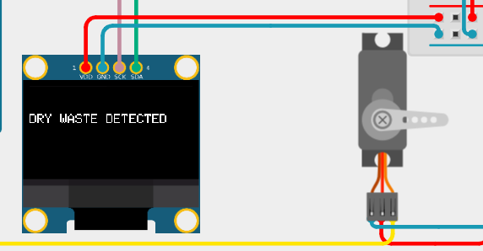
Fig 5.3: Dry waste detected — flap servo directs waste to the dry compartment
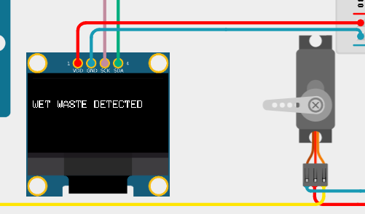
Fig 5.4: Wet waste detected — flap servo directs waste to the wet compartment

5.3 Compartment Fill-Level Monitoring
Independently of the lid and sorting logic, the two top-mounted ultrasonic sensors continuously measure the distance to the surface of the waste inside the dry and wet compartments respectively. If the measured distance in a compartment falls below the full-level threshold (5 cm), that compartment is flagged as full. The system reacts as follows:
▸ Dry compartment full only → buzzer beeps once; OLED shows a dry-full message.
▸ Wet compartment full only → buzzer beeps twice; OLED shows a wet-full message.
▸ Both compartments full → buzzer beeps three times; OLED shows “BOTH COMPARTMENTS FULL – SERVICE REQUIRED.”
Alert flags ensure that each condition is only announced once per full event rather than repeating every loop cycle, and the flags reset automatically once the corresponding compartment is emptied below the threshold.
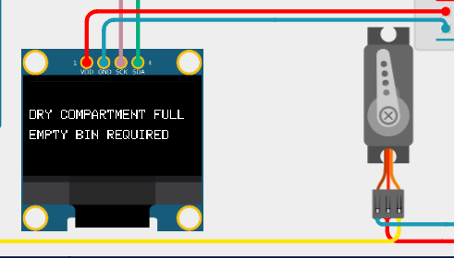
Fig 5.5: Dry compartment full — alert displayed on OLED
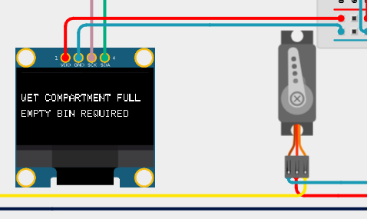
Fig 5.6: Wet compartment full — alert displayed on OLED
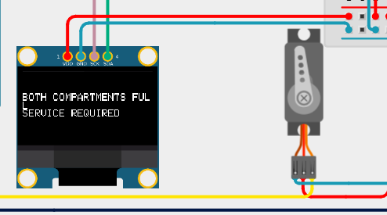
Fig 5.7: Both compartments full — service-required alert

6. Hardware Components (Bill of Materials)
Component | Quantity | Purpose
Arduino Uno | 1 | Main microcontroller / control unit
Ultrasonic Sensors (HC-SR04) | 3 | Lid trigger + dry-level + wet-level sensing
Soil Moisture Sensor | 1 | Wet vs dry waste classification
Servo Motors (SG90) | 2 | Lid actuation and flap actuation
OLED Display (0.96″, I2C) | 1 | Real-time status display
Buzzer | 1 | Audible full-bin alerts
Connecting Wires | As required | Circuit interconnections
Breadboard | 1 | Prototyping platform

7. Software and Libraries
▸ Arduino IDE – firmware development and upload
▸ Wire.h – I2C communication with the OLED display
▸ Adafruit_GFX.h and Adafruit_SSD1306.h – OLED graphics and text rendering
▸ Servo.h – control of the lid and flap servo motors
▸ Tinkercad Circuits – circuit simulation and testing prior to physical assembly

8. Circuit Design and Simulation
The complete circuit was designed and validated in Tinkercad Circuits before physical implementation. The Arduino Uno acts as the central controller, interfacing with all three ultrasonic sensors, the soil moisture sensor, both servo motors, the buzzer, and the OLED display over a shared breadboard power rail. The layout below shows the full simulated assembly.

Fig 8.1: Complete circuit layout of the AutoSort Bin in Tinkercad
The bin-door assembly (bottom ultrasonic sensor and lid servo) is wired separately from the two compartment-level sensors, keeping the entry-detection logic and the fill-monitoring logic electrically and functionally distinct, as shown in the component-level views below.
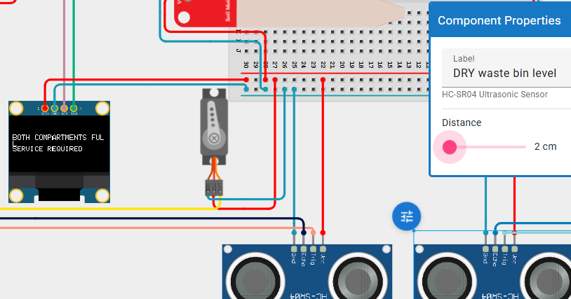
Fig 8.2: DRY waste bin level sensor configuration and compartment wiring

9. Results and Discussion
The system was simulated end-to-end in Tinkercad and behaved as intended across all test conditions. The main lid opened reliably whenever an object was placed within the 20 cm trigger range of the bottom sensor and closed automatically after the fixed delay. Waste with a simulated moisture value below the threshold was consistently routed to the dry compartment, while waste at or above the threshold was routed to the wet compartment, with the OLED correctly reflecting each classification. Compartment-level monitoring correctly distinguished all three alert states — dry-only full, wet-only full, and both full — each producing its own distinct buzzer pattern (1, 2, and 3 beeps respectively) alongside the matching OLED message.
Test Condition | Expected Behaviour | Observed Result
Object within 20 cm of front sensor | Lid opens, waits, then closes | As expected
Moisture value < 500 (dry) | Flap routes to dry side, OLED shows DRY WASTE DETECTED | As expected
Moisture value ≥ 500 (wet) | Flap routes to wet side, OLED shows WET WASTE DETECTED | As expected
Dry compartment distance < 5 cm | 1 beep + dry-full message | As expected
Wet compartment distance < 5 cm | 2 beeps + wet-full message | As expected
Both compartments < 5 cm | 3 beeps + service-required message | As expected

10. Advantages
▸ Removes dependency on manual, user-driven waste segregation.
▸ Touch-free lid operation improves hygiene.
▸ Independent monitoring of dry and wet compartments allows targeted, efficient collection scheduling.
▸ Distinct buzzer patterns allow status recognition without needing to view the display.
▸ Low-cost components make the design suitable for households, offices, and educational institutions.

11. Applications
The modular sensor-and-actuator design of AutoSort Bin makes it adaptable to a wide range of environments where automated, hygienic waste segregation is valuable:
▸ Smart homes and residential apartments — automated dry/wet segregation right at the source, before waste ever reaches a municipal collection point.
▸ Educational institutions and college campuses — builds consistent waste-segregation habits among students and reduces manual sorting effort for housekeeping staff.
▸ Corporate offices and IT campuses — hygienic, touch-free disposal in shared pantry and cafeteria areas.
▸ Hospitals and healthcare facilities — touch-free operation reduces cross-contamination risk during waste disposal.
▸ Railway stations, airports, and public transit hubs — handles high foot-traffic waste disposal while flagging compartments that need urgent emptying.
▸ Shopping malls, restaurants, and food courts — automatically separates wet food waste from recyclable dry waste (paper, plastic, packaging).
▸ Smart-city and municipal waste management — fill-level data from multiple units can be aggregated to optimize garbage-truck collection routes and schedules.

Key Takeaway
Because sensing, sorting, and alerting are all handled independently by low-cost, off-the-shelf modules, the same design can scale from a single household bin to a networked fleet of public smart bins with minimal modification.

12. Limitations and Future Scope
▸ Ultrasonic sensors can be affected by irregular waste surfaces, which may require periodic threshold calibration.
▸ The current design has no wireless connectivity; adding a Wi-Fi/GSM module (e.g., ESP8266/ESP32 or SIM800L) would enable remote fill-level notifications to a municipal dashboard or mobile app.
▸ A solar-powered variant could make the unit suitable for outdoor public spaces.
▸ Additional segregation categories (e.g., metal or plastic) could be added using extra sensors, such as an inductive proximity sensor.
▸ A data-logging module could be integrated to track waste generation trends over time.

13. Conclusion
AutoSort Bin successfully demonstrates an automated, sensor-driven approach to waste segregation and bin-level monitoring using low-cost, readily available components. By combining ultrasonic sensing, moisture-based classification, servo actuation, and real-time OLED/buzzer feedback, the system reduces manual effort, improves hygiene, and helps prevent bin overflow. The project validates that meaningful automation in solid-waste management is achievable even at the small-scale embedded-systems level, and it lays a practical foundation for future IoT-connected smart-bin deployments across homes, institutions, and public spaces.

14. References
1. Arduino Official Documentation – https://www.arduino.cc/reference/en/
2. Adafruit SSD1306 OLED Library Documentation – Adafruit Industries.
3. HC-SR04 Ultrasonic Sensor Datasheet.
4. SG90 Micro Servo Motor Datasheet.
5. Tinkercad Circuits – Autodesk, https://www.tinkercad.com/

